Benefits Management Framework

Contents
Overview 2
Benefit Management process overview 2
Benefits management lifecycle 3
Identify 4
Plan 5
Deliver 6
Review 6
Summary 7
Benefits Type and Category 8
Benefit Maturity Level 9
Benefit Management - Eligibility Rules 10
Definition 10
Validation 11
Templates 11
Guide to completing templates 11
Examples 11
Support 12
Benefit Management Governance 12
Operations Committee 12
Senior Responsible Officer 12
Benefit Owners 12
Benefit managers 13
Decisions 14
Enterprise Project Support (& Portfolio Benefit Manager) 14
Benefit Tracking and Reporting 14
Tracking Realisation (Requirements) 15
Stakeholder Reporting (Requirements) 15
Dashboard Reporting (Requirements) 15
Frequently Asked Questions 16
1. Why do we need to actively manage benefits and dis-benefits? 16
2. Does benefit management apply to all change? 16
3. How do you tell the difference between benefits and outcomes etc.? 17
Guidelines for Reporting Status for Benefit Measure - within StrategyDotZero 18

Overview
This Benefits Management Framework is managed by the Enterprise Project Support with documentation available on the Enterprise Project Support portal on the Department’s intranet.
The framework has been developed to work in conjunction with both the Project Management Framework and the wider context of decisions around departmental investment in change. The framework aims to ensure a consistent streamlined approach to managing and realising benefits enabled by changes to the Department.
The purpose of the Benefits Management Framework is to provide:
- A framework of best practice principles drawn from latest experience in setting up and managing programs across the public sector and within the department;
- A standard approach to benefits identification, planning, management and realisation for the department’s Executive, Senior Responsible Owners (SROs), Division/Branch Heads, Program Directors/Managers, Business Change Managers, Project Managers, business analysts and program/project management office staff;
- Consistent terminology and benefits categorisation;
- A determinant of the maturity level of the department’s capability in portfolio, program and project management; and
- A contribution towards increased departmental management capability.
To facilitate reporting of benefit realisation, the benefit module in StrategyDotZero tool has been configured to allow for key components of the Benefit Profile, and to record tracking of benefit realisation.

Benefit Management process overview
The benefits management process is developed to work in conjunction with both the Project Management Framework and the wider context of decisions around departmental investment change.
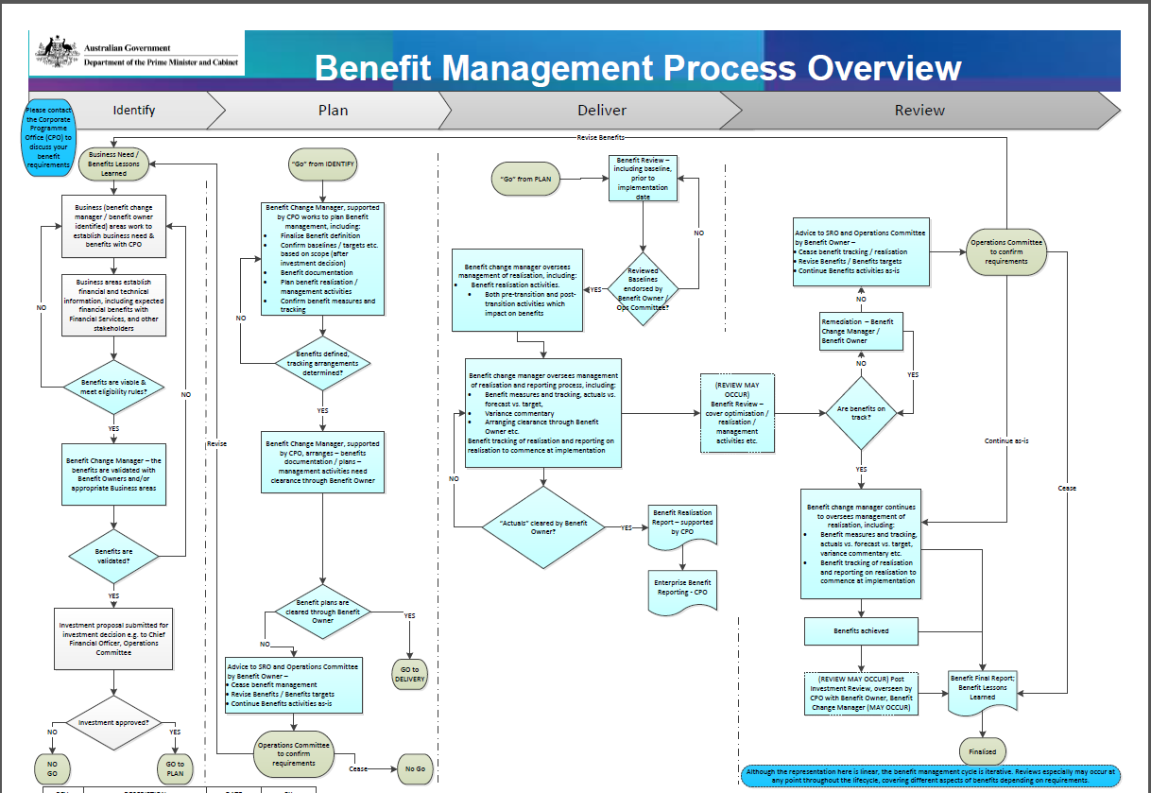
Top of Form

You can download a copy of the from the benefits management page in the EPS portal (eps.strategydotzero.com)

Benefits management lifecycle
The Benefits Management Lifecycle provides an overview of the various stages and related activities involved in the end to end benefits management process. The Lifecycle sets the context of how the benefits journey evolves over time and what critical activities are carried out across various stages of this journey/lifecycle.

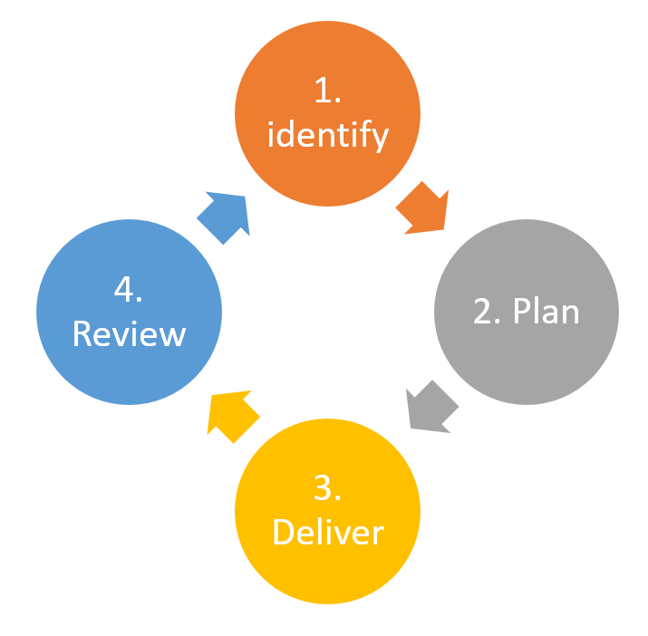

Identify
Business areas should start to identify potential benefits as soon as possible. The recommendation is to establish a benefits-led approach to change (led by an initiative/project), where applicable.
Expected benefits to be recorded in the Concept / Business Case:
- Benefit type, category and name
- Baselines and forecasts (for each benefit).
- Timeframes (for each benefit).
- Need to retain information around Assumptions; calculations; and sources of information – even if it's not recorded in the Concept/Business Case.
NOTE: All this information may need to be updated / confirmed; especially if the investment decision changes the scope of the proposed change.
Benefit managers
- Identify and quantify the benefits (and dis-benefits) with the support of relevant stakeholders (and the Program Manager and members of the project team, if in place).
- Begin to develop the Benefit Profiles (the information used in the Project Brief / Business case can be recorded in the Benefit Profiles).
- Provide information to support the creation of the Benefit Realisation Plan (with the Program Manager, if under a program structure).
Benefit Owners
- Validate the Benefit Profiles prepared by the Benefit manager.
EPS
- Engage as early as possible with areas establishing their business need (for change) to encourage the use of a benefit-led process.
- Work with business areas to identify, define and quantify any expected benefits, applying the Eligibility Rules.
- Support business areas in establishing ownership of benefits and communicate about benefit roles and responsibilities.
- Work with business areas to document the information that they are gathering about benefits.

Plan
Business areas should confirm benefits post-investment decision. That is, has the scope changed, was there a flow-on impact on benefits etc.
Benefit action and information required:
- Confirm benefits.
- Baselines, targets, timeframes, assumptions, calculations, and sources of information.
- Quantify (confirmed) benefits and dis-benefits – including how benefit realisation will be tracked.
- Benefit measures for tracking realisation are identified.
- Define (confirmed) benefits and dis-benefits; describe the nature of the strategic alignment, what outcomes, capabilities, products should be in place to enable benefit realisation.
- Plan Benefit Management activities – what activities need to take place in order to realise benefits.
- Project planning / change management planning etc. – consider benefit management (benefit realisation, tracking, reporting etc.).
- Benefit Review – environmental scan, any emergent benefits etc.
Benefit managers
- Continue to drive the development of benefits and dis-benefits, and associated artefacts, with the support of relevant stakeholders (and the project team).
- Work with the project team to ensure that benefits and dis-Benefits are considered in Project and Change Management planning, including benefit realisation, tracking and reporting are considered when developing requirements, planning activities etc.
- Define (confirmed) benefits and dis-benefits, describe the nature of the strategic alignment, what outcomes, capabilities, products should be in place to enable benefit realisation.
- Quantify (confirmed) benefits and dis-benefits – identifies measures for tracking benefit realisation.
- Develop the Benefit Profiles, arranges sign-off / agreement of the Benefit Profiles (Benefit Profiles are living documents).
- Provide information to support the creation of the Benefit Realisation Plan (with the Program Manager, if under a program structure) (Benefit Realisation Plans are living documents).
Benefit Owners
- Agrees with the Benefit Profiles, benefit realisation planning activities prepared by the Benefit manager.
EPS
- Work with business areas to document the information that they are gathering about benefits.
- Support Benefit managers through benefits processes.

Deliver

Business areas should review baselines prior to implementation of any changes, especially where there has been significant lag time between project mandate and delivery.
Benefit information required
- Baselines reviewed prior to implementation of change.
- Benefit tracking / reporting confirmed prior to implementation of change and commences once change is delivered.
- Reporting should include Forecast, Actuals etc.
- Benefits are actively managed – based not only on environmental factors but also on results of tracking realisation.
- If tracking shows results are not trending toward targets then what other activities are planned / required (training, communications etc.).
- If tracking shows that performance is exceeding expectation, consider benefit optimisation.
- Benefit Review – environmental scan, any emergent benefits etc.
Benefit managers
- Work with the project team to ensure that Benefits and Dis-Benefits are considered in Project and Change Management planning and delivery. Any changes to the Project or Change Management activities – what is the impact on benefits.
- Maintain the Benefit Profiles and Benefits Realisation Plan (will work with the Program Manager to do this if there is a Program Manager).
- Ensure there is no double-counting of benefits within the project.
- Work on behalf of benefit owners to ensure benefit tracking / reporting occurs and sets business performance deviation levels and early-warning indicators (e.g. tolerances).
- Contribute to Closure Report / Post Implementation Review (for project), as required.
Benefit Owners
- Monitor the successful delivery of enabling changes and business changes.
- Collect and reports data to evidence the realisation of benefits (ensures Tracking / Reporting occurs).
- Contribute to Closure Report / Post Implementation Review (for project), as required.
EPS
- Work with benefit managers to support them through benefit processes.

Review

Benefit reviews can take place at any stage throughout the benefit lifecycle – with the scope of the review depending on timing and requirements.
Benefits may or may not go through a final review e.g. a Post Investment Review. However, when Benefit Realisation is completed a final benefit report should be produced to advise that the lifecycle is being finalised, even if no review has been indicated.
Benefit information required:
The nature of a benefit review will dictate the Baselines reviewed prior to implementation of change
- Benefit reviews at start-up.
- Gateway Reviews.
- Benefit reviews in-flight etc.
Benefit managers
- Maintain the Benefit Profiles and Benefits Realisation Plan (will work with the Program Manager to do this if there is a Program Manager.)
- Work on behalf of benefit owners to ensure benefit tracking / reporting occurs and sets business performance deviation levels and early-warning indicators (e.g. tolerances).
- Take part in Benefit Reviews as required.
- Develop the Final Benefit Report on behalf of Benefit Owners, SRO etc.
Benefit Owners
- Monitor the successful delivery of enabling changes and business changes.
- Collect and reports data to evidence the realisation of benefits (ensures Tracking / Reporting occurs).
- Agree the Final Benefit Report.
EPS
- Work with benefit managers to support them through benefit processes.
- Support Benefit Reviews, as required.

Summary
Some of the key activities associated with each stage of the lifecycle are listed below:
IDENTIFY
- Identify benefits early during concept definition and business case development
- Identify benefit manager and owners or appropriate business areas
- Validate benefits
PLAN
- Develop Benefits Management plan
- Finalise benefit definition
- Confirm benefit measures and tracking
- Capture baseline and target values
- Plan benefit realisation schedule
- Get approval from the benefit owner
DELIVER
- Monitor and track benefits (actuals vs forecast vs target)
- Get ‘actuals’ cleared by benefit owner
- Report on benefit realisation
REVIEW
- Review and revise benefits
- Continue benefits activities as-is
- and embed benefits management approach
- Re-baseline benefit profiles and realisation schedule
- Initiate new projects/programs to optimise benefit realisation
- Document final benefit report and lessons learnt

Benefits Type and Category
Benefit classification increases understanding of the nature of benefits, assists analysis and improves communication. It helps stakeholders understand expectations and it raises awareness of the impacts on other stakeholders. It will also assist those responsible for change to identify potential problem areas and to plan mitigating action.

Benefits can be classified into the following types:
- Financial (cashable) – those benefits that can be quantified and valued in financial terms e.g. cost savings, revenue generation.
- Financial (non-cashable) – those benefits that can be quantified and valued in financial terms but cannot be shown as savings e.g. cost avoidance
- Non-financial – those benefits that can be quantified but are difficult to value in financial terms e.g. improved resilience.
Some program and projects will continue to realise benefits well beyond the end of the program because:
- Benefits may take longer to materialise than it is reasonable to maintain the program/project structures;
- Other benefits may have to be realised, but will need to be owned and managed to pre-arranged target levels that are yet to be achieved;
- Benefits can manifest themselves at any time and may not require the program structure to be in place to realise them;
- Beyond the end of the program, the Business Change Manager would continue to have responsibility for realisation even though the formal structures may well have been disbanded; and
- Unexpected benefits should be captured and reported to ensure that the full value of the program is recognised.
Categorising benefits can assist organisations to better model priorities and planning and ensure that there is a balanced portfolio of benefits arising from any change initiatives. For each of the benefit types, there are benefit categories that have been identified as shown in the image below.
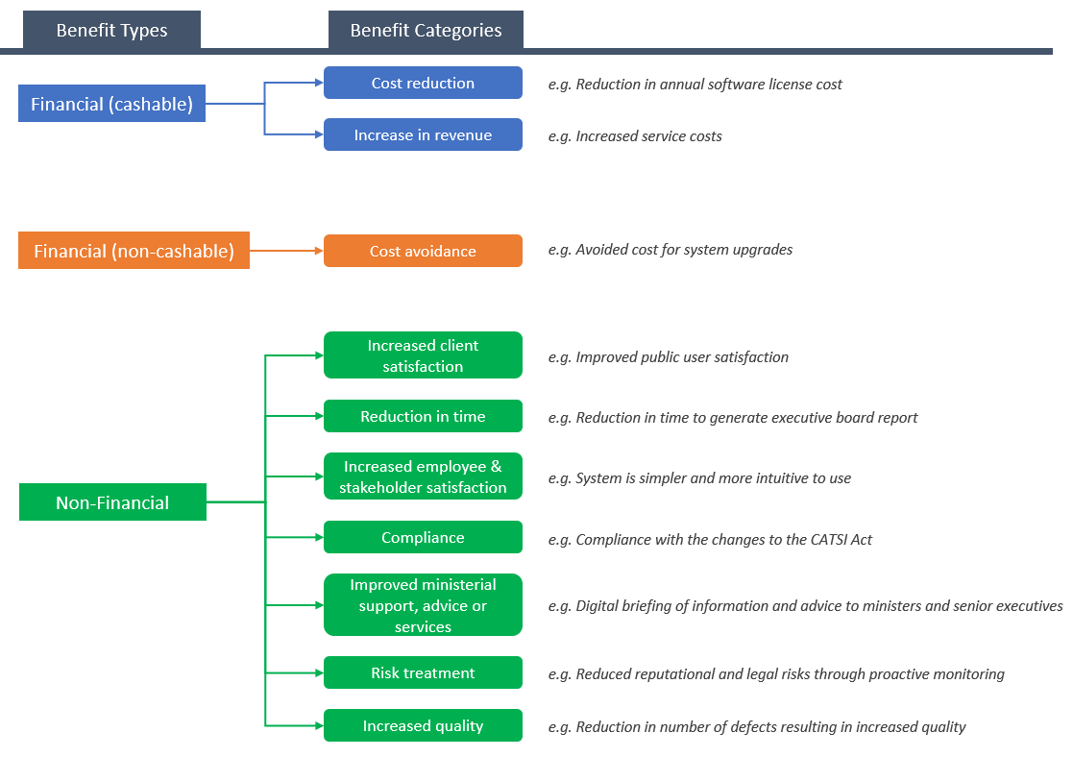
This framework (based upon MSP) categorises benefit types and classifications to increase the understanding of the nature of benefits.

Benefit Maturity Level
Benefits mature as they progress through their lifecycle which is aligned to the Project Management lifecycle. There are three levels of benefit maturity as shown below.

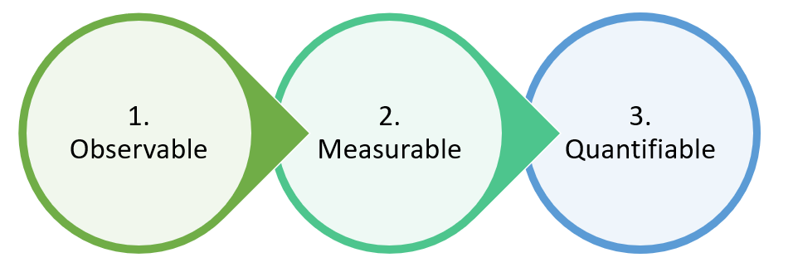
- Observable – An observable benefit record may have only few attributes captured/identified –
    - Type
    - Category
    - Benefit Name
    - Owner
    - Manager
Usually the benefits are found to be in an observable maturity in the very early stages of identification. A business area might identify high level benefits during the concept definition without detailed information around the measures, baseline and target values etc.
- Measurable – A measurable benefit is one that has at least one measure associated to it. E.g. Benefit – Reduced operation cost of Team X
Measure – Reduced number of FTEs

- Quantifiable – Quantifiable benefits are those that have measures associated to them along with the baseline, target values, source of measurement, frequency of measurement and realisation dates.
E.g. Benefit – Reduced operation cost of Team X
Measure – Reduced number of FTEs from X to Y
Measure metric - # (number)
Baseline – X
Target – Y
Source – HR System
Frequency of measurement – Quarterly
Start Date – dd/mm/yyyy
End Date – dd/mm/yyyy

Benefit Management - Eligibility Rules
The Benefit Management eligibility rules, to be used to validate all identified benefits. This approach will ensure consistency in identifying, defining and mapping benefits, allowing for:
- Portfolio oversight of benefits
- Effective management
- Improving the ability of the Department to ensure correct attribution and prevent double-counting of benefits.
The eligibility rules are applied as part of identifying benefits.

Definition
A benefit must meet the definition to be claimed as a benefit.
​Benefit
A measurable improvement resulting from an outcome perceived as an advantage by one or more stakeholders, which contributes towards one or more organisational objectives.
​
There is a difference between outcomes and benefits.
- Outcomes are the results of change; they are the manifestation of part or all of the new state (conceived in the Blueprint);
- Benefits are the measurable improvement resulting from outcomes, that is, the advantage that the Department realises from achieving a new end state.

​

Validation
Benefits must be able to be validated using these criteria.
​Description – What precisely is the benefit?
​Observable Outcomes – What are the verifiable differences that will be noticeable between pre- and post-implementation of the change?
​Attribution – Where will this benefit arise? Can this project/program claim its realisation? Is the accountability and responsibility for delivering the change clear and agreed?
​Measurement – How and when will the achievement of the benefit be measured?

Templates
There are three templates required to capture all the necessary information for benefit management.
- Benefit Map – A benefits dependency map clearly shows the high-level relationships between the drivers of the change, benefits and strategic direction of the Department
- Benefit Profile - To capture the full details of the benefit, including the definition, risks, stakeholders, assumptions, timeframes and how the benefits will be measured. ​
- Benefit Management Plan - To summarise benefit owners, activities developed to manage and enable realisation, and reporting arrangements.

Benefit Management Governance
This section provides a guide to governance roles within Benefit Management. The purpose of the guide is to promote effective and robust governance of benefit management requirements.

Operations Committee
- The Operations Committee has oversight, according to its Terms of Reference, for the operational area of Financial Management, including the finance strategy and financial issues, including annual and forward budgets, capital investment decisions, compliance reporting and monthly financial reporting.
- Accountability for benefits expected from investment decisions approved by the Operations Committee will rest with the Operations Committee.
- Specific accountability for individual benefits may be assigned to individual committee members, based on:
  - Their area of responsibility within PMC (the Department) means that the benefit/s impact specifically within that area.
  - Their area of responsibility within the Department means that they have the ability to enable or ensure benefit realisation.
- If accountability is assigned to an individual role, the accountability will remain with the role.
- The Operations Committee will make the final determination, based on recommendations from the Senior Responsible Officer (SRO) and Benefit Owners that benefits (and dis-benefits) are finalised or achieved, or that benefits may need to be revised or reviewed.

Senior Responsible Officer
- The SRO is the single individual with overall responsibility for ensuring that the project or program meets its objectives and delivers the projected benefits.
- Will report directly to the Operations Committee on:
  - Delivery of benefits / dis-benefits.
  - Validation of the benefits / dis-benefits claimed by the project or program.
- The SRO, with regards to benefits, will be at either the First Assistant Secretary (SES Band 2) level or Deputy Secretary (SES Band 3) level, depending on the impact of the change being implemented.
- The SRO role, with regards to benefits, may last beyond the life of the project or program – until the end of the Benefit Management lifecycle.

Benefit Owners
- The benefit owner is the individual responsible for realisation of a specific benefit; benefit owners may be responsible for more than one benefit.
- Benefit owners report directly to the SRO of the project or program.
- They should be either on the project or program board, or represented on the project or program board.
- Benefits owners are responsible for:
  - Validating the expected benefits and dis-benefits prior to the investment submissions being submitted to the Operations Committee.
  - Signing-off on Benefit planning activities.
  - Endorsing reviewed baselines prior to project / program implementation.
  - Clearing the benefit realisation 'actuals' and 'forecasts' used in benefit reporting.
  - Providing advice and recommendations to the SRO and Operations Committee regarding 'go and no-go' decisions around benefits.
- Benefit ownership will be assigned based on:
  - Ensuring that the role assigned with the responsibility has sufficient authority to enable benefit realisation, including influencing change within the required areas.
  - A role's area of responsibility within the department, if the benefit/s impacts specifically within that area.
  - A role's area of responsibility within the department means that they have the ability to enable or influence benefit realisation.
- The benefit ownership responsibility will generally remain with the role, and should form part of any handover.
- The benefit ownership will be at either the First Assistant Secretary (SES Band 2) level or Assistant Secretary (SES Band 1) level, depending on the impact of the change being implemented.
- The Benefit Owner role will last until the end of the Benefit Management lifecycle.

Benefit managers
- The Benefit manager (BCM) role is normally represented by a subject matter expert from the business area. The role is a bridge between project and ongoing business and IT operations. The BCM is responsible for benefit management and ensuring that the continued accrual of benefits can be achieved and measured by identifying and implementing the expected improvements in business operations as projects deliver their products or services into operational use.
- Identify and quantify the benefits, with support of relevant stakeholders and members of the project team
- Develop and maintain the Benefit Realisation Plan / Benefit Profiles and validates them with the Benefit Owner
- Maintain engagement with key individuals responsible for benefits delivery within operational areas
- Set business performance deviation levels and early-warning indicators to support benefit realisation
- Initiates benefit reviews after the project has closed, if applicable
- Benefit responsibilities are normally associated with the role rather than the individual and should form part of any handover of responsibilities.
The role will extend for the life of the benefits (as per the Profile)
*NB Full roles and responsibilities are available through the Enterprise Project Support

Decisions
There are benefit related decisions that do require a specific level of authority.
- All financial benefits (cashable) must be validated by a business / IT owner of the area where the benefits will impact and the benefit owner, prior to being submitted for an investment decision, e.g. as part of a business case to the Operations Committee. The business / IT owner must, at least, be at the First Assistant Secretary level (SES Band 2 level).
- All non-financial benefits and financial benefits (non-cashable) must be endorsed by a business / IT owner of the area where the benefits will impact and the benefit owner, prior to being submitted for an investment decision. The business owner / IT must, at least, be at the Assistant Secretary level (SES Band 1 level).

Enterprise Project Support (& Portfolio Benefit Manager)
- The Enterprise Project Support (EPS) and the Portfolio Benefit Manager have no governance role within benefit management.
- EPS and the Portfolio Benefit Manager will provide support and guidance at the project and program-level.
- Enterprise-level benefits reporting and oversight rests with the Portfolio Benefit Manager, who may also participate post-investment reviews.

Benefit Tracking and Reporting
This section covers basic benefit reporting information. Actual benefit reporting is carried out through the StrategyDotZero tool.
There are three scenarios that are covered:
- Reports arranged and received by the Benefit Owner and Benefit manager to track benefit realisation.
- Reports produced by the Benefit Owner and BM to keep their stakeholders informed about the progress of benefit management and benefit realisation.
- Program and departmental-level benefit reporting developed and produced by the Enterprise Project Support.

Tracking Realisation (Requirements)
- As the benefit measures are determined, information will be required to prove how realisation is progressing – this is referred to as Management Information (MI).[1]
- The information may be gathered within the benefit owners own area or it might be a report generated by another area.
- The MI should be used to actively manage benefit realisation.
- If there are any constraints to gaining the information, for example, it's only produced twice a year or it is received quarterly but takes three weeks in order to actually analyse it sufficiently to make it fit-for-purpose, then this should be noted within the benefit profile.
- If there are any costs or resources associated with gaining the MI then it should be included within the Benefit Realisation Plan.
- Collecting MI should be an automated process where possible, or at least the impost should be commensurate with the benefit to be realised.
- While the MI is received separately, the results should be able to be recorded within the Benefit section of the StrategyDotZero tool.
(Responsibility: Benefit Owner)

Stakeholder Reporting (Requirements)
- The MI to track benefit realisation is recorded by Benefit Owners / BCMs in the Benefit section of the StrategyDotZero tool, on an ongoing basis.
- Stakeholder reports will be produced on a quarterly basis from the Strategy Dot Zero tool, this will include:
  - Actuals.
  - Forecasts.
  - Variance commentary.
  - Actions being undertaken to manage or improve ongoing benefit realisation.
  - Separate benefit management activity, e.g. if a benefit review is underway.
- This information should be cleared by the Benefit Owner prior to being made available to other stakeholders, e.g. Senior Responsible Owner.
(Responsibility: Benefit Owner)

Dashboard Reporting (Requirements)
- The MI to track benefit realisation is recorded by Benefit Owners / BCMs in the Benefit section of the StrategyDotZero tool, on an ongoing basis.
- Other benefit information is also recorded within the tool, including baselines, targets, type, category, strategic alignment to the organisational objectives.
- The benefit owners will be reporting Actuals, Forecasts etc. on a quarterly basis.
- All of this information will be used to:
  - Produce Dashboard reports.
  - Map benefits at the portfolio-level to reduce instances of double-counting.
  - Produce an enterprise benefit realisation plan.
(Responsibility: Enterprise Project Support)
[1] Management Information may have specific meanings within areas dealing with, for example, ICT or statistics. For this purpose, it's literally the information used to manage (and track) realisation.

Frequently Asked Questions
1. Why do we need to actively manage benefits?
When actively managed:
Benefits – establish at the start why a change is valuable for the Department
- Benefits can be used as part of the value judgment / investment decision for implementing a change; and help to demonstrate that a change will further the Department's organisational objectives.
- Value is representative of both monetary and non-monetary measurable improvement for the Department.
Benefits – prove the success of implementing and embedding change (short term and long term)
- At the project (or program) level benefits are useful to judge whether a change has been implemented and embedded successfully.
- At the departmental level realisation of benefits can be used to establish that the capability exists for successfully delivering change.
Benefits – valuable as a planning mechanism
- At the departmental level, benefits should be used to help advance the department toward its objectives over the longer term, as benefits are normally realised over a longer period than the introduction or implementation of a product/output or outcome.
- Can be used to provide an insight into long term investment decisions for the department; looking at the proportion of money invested in enabling specific organisational objectives.
- Can be used in a benefits-led approach to design a solution for a project to deliver.
Dis-Benefits (Risks)
- Dis-benefits are nothing but risks to the program or project and has to be managed accordingly.
2. Does benefit management apply to all change?
Not all change programs or projects will be benefits-led.
Benefits form one factor in informing any investment decisions. However, there are other criteria which are taken into account.
Who is expected to apply Benefit Management?
- Projects or programs with identified benefits (financial and non-financial) are expected to apply Benefit Management – this includes the processes and templates.
- Projects or programs required to implement change, for example, due to legislative change or ICT requirements, where there are also associated identified benefits; or where emergent benefits are recognised. An example of this may be where the legislative change itself does not lead to a measurable improvement. However, there are associated changes with the way that the department operations (changes to processes etc. as part of the same project) which do generate measurable improvements.
Who is NOT expected to apply Benefit Management
- Projects or programs required to implement change, for example, due to legislative change or ICT requirements, where there are no associated identified measurable improvements. An example of this may be where a change of software is required – one version / brand of software is no longer going to be supported, the new software brings no specific measurable improvements along with it aside from enabling continued operations.
- Projects with no identified benefits. If the project enables later benefits (through another project) then Benefit Management would only apply to the later project.

3. How do you tell the difference between benefits and outcomes etc.?
The following table provides definitions, and examples of some of the terms you'll find on a benefit map and benefit profile. Further definitions can also be found in the benefit management Glossary of terms.
 | Objective | Output / Product | Outcome | Benefit | Measure (of realisation)
Definition | The intended goal of a program, project or organisation. Objectives describe what the project aims to achieve. | The tangible or intangible artefact produced, constructed or created as a result of a planned activity.  AND  An input or output, whether tangible or intangible, that can be described in advance, created and tested. | The result of change, normally impacting real-world behaviour or circumstances. Outcomes are desired when a change is achieved as a result of the activities undertaken to effect the change; they are the manifestation of part or all the new state conceived in the blueprint. | (Benefit) A measurable improvement resulting from an outcome perceived as an advantage by one or more stakeholders, which contributes towards one or more organisational objectives. | Measures are used to track / indicate progress towards a benefit target.
Example | Implement e-commerce  Provide more services to customers online  Improve customer service | A new tool designed to facilitate customer self-service online  AND/OR  New business processes designed to facilitate customer self-service online | Organisation moves to a digital service model | (Benefit) Improvements in services to customers  (NB additional details of why this is a benefit to the organisation would be added as part of the benefit description) | (E.G.) Decreased processing time  (E.G.) Decreases in error rate (transcribed information)  (E.G.) Improved turnaround time for customers (faster processing) etc.

Guidelines for Reporting Status for Benefit Measure - within StrategyDotZero
Status | Information | ​
To Commence | This status should only be recorded prior to any benefit activities being undertaken. This includes those activities and required information outlined in the benefit management process for Identify, Plan, Deliver, and Review. | ​
On Track (Green) | Financial measures  If the financial tracking for a benefit are underperforming with a variance of less than or equal to 5% (forecast or actual) within expected target, then the benefit is considered to be on track.  If the financial tracking for a benefit are over-performing with a variance of less than or equal to 110% (forecast or actual) then the benefit is considered to be on track. | Non-Financial measures  If the non-financial tracking for a benefit are underperforming with a variance of less than or equal to 5% (forecast or actual) within target, then the benefit is considered to be on track.  If the non-financial tracking for a benefit are over-performing with a variance of less than or equal to 110% (forecast or actual) then the benefit is considered to be on track.
Delayed (Amber) | Financial measures  If the financial tracking for a benefit are underperforming with a variance of greater than 5% (forecast or actual) within expected target but less than or equal to 15% variance then the benefit is considered to be delayed and remedial action is required, and comments must be provided by Benefit Owner / BCM re reason and remediation.  If the financial tracking for a benefit are over-performing with a variance of greater than 110% (forecast or actual) but less than 120% then the benefit itself may require review in terms of what expectations are realistic and comments addressing this must be provided by Benefit Owner / BCM. | Non-Financial measures  If the non-financial tracking for a benefit are underperforming with a variance of greater than 5% (forecast or actual) within target but less than or equal to 15% then the benefit is considered to be delayed and remedial action is required, and comments must be provided by Benefit Owner / BCM re reason and remediation.  If the non-financial tracking for a benefit are over-performing with a variance of greater than 110% (forecast or actual) but less than 120% then the benefit itself may require review in terms of what expectations are realistic and comments addressing this must be provided by Benefit Owner / BCM.
Off Track (Red) | Financial measures  If the financial tracking for a benefit are underperforming with a variance of greater than 15% (forecast or actual) within target then the benefit is off track and immediate remedial action must be undertaken, by Benefit Owner / BCM – comments to be provided.  If the financial tracking for a benefit are over-performing with a variance of greater than 120% (forecast or actual) but then the benefit requires review in terms of what expectations are realistic and the Benefit Owners must determine a course of action and provide comments. | Non-Financial measures  If the non-financial tracking for a benefit are underperforming with a variance of greater than 15% (forecast or actual) within target, then the benefit is off track and immediate remedial action must be undertaken by Benefit Owner / BCM – comments to be provided.  If the non- financial tracking for a benefit are over-performing with a variance of greater than 120% (forecast or actual) but then the benefit requires review in terms of what expectations are realistic and the Benefit Owners must determine a course of action and provide comments.
Harvested | For both financial and non-financial measures this status should be keyed when the benefit has been realised. | ​
Financial indicators to be confirmed with Financial Services Division

